**S3 Bucket Creation Assignment**

**Problem Statement: You work for XYZ Corporation. Their application requires a storage service that can store files and publicly share them if required. Implement S3 for the same. Tasks**

**To Be Performed:**

**1. Create an S3 Bucket for file storage.**

**2. Upload 5 objects with different file extensions.**

1. Create an S3 Bucket for file storage.

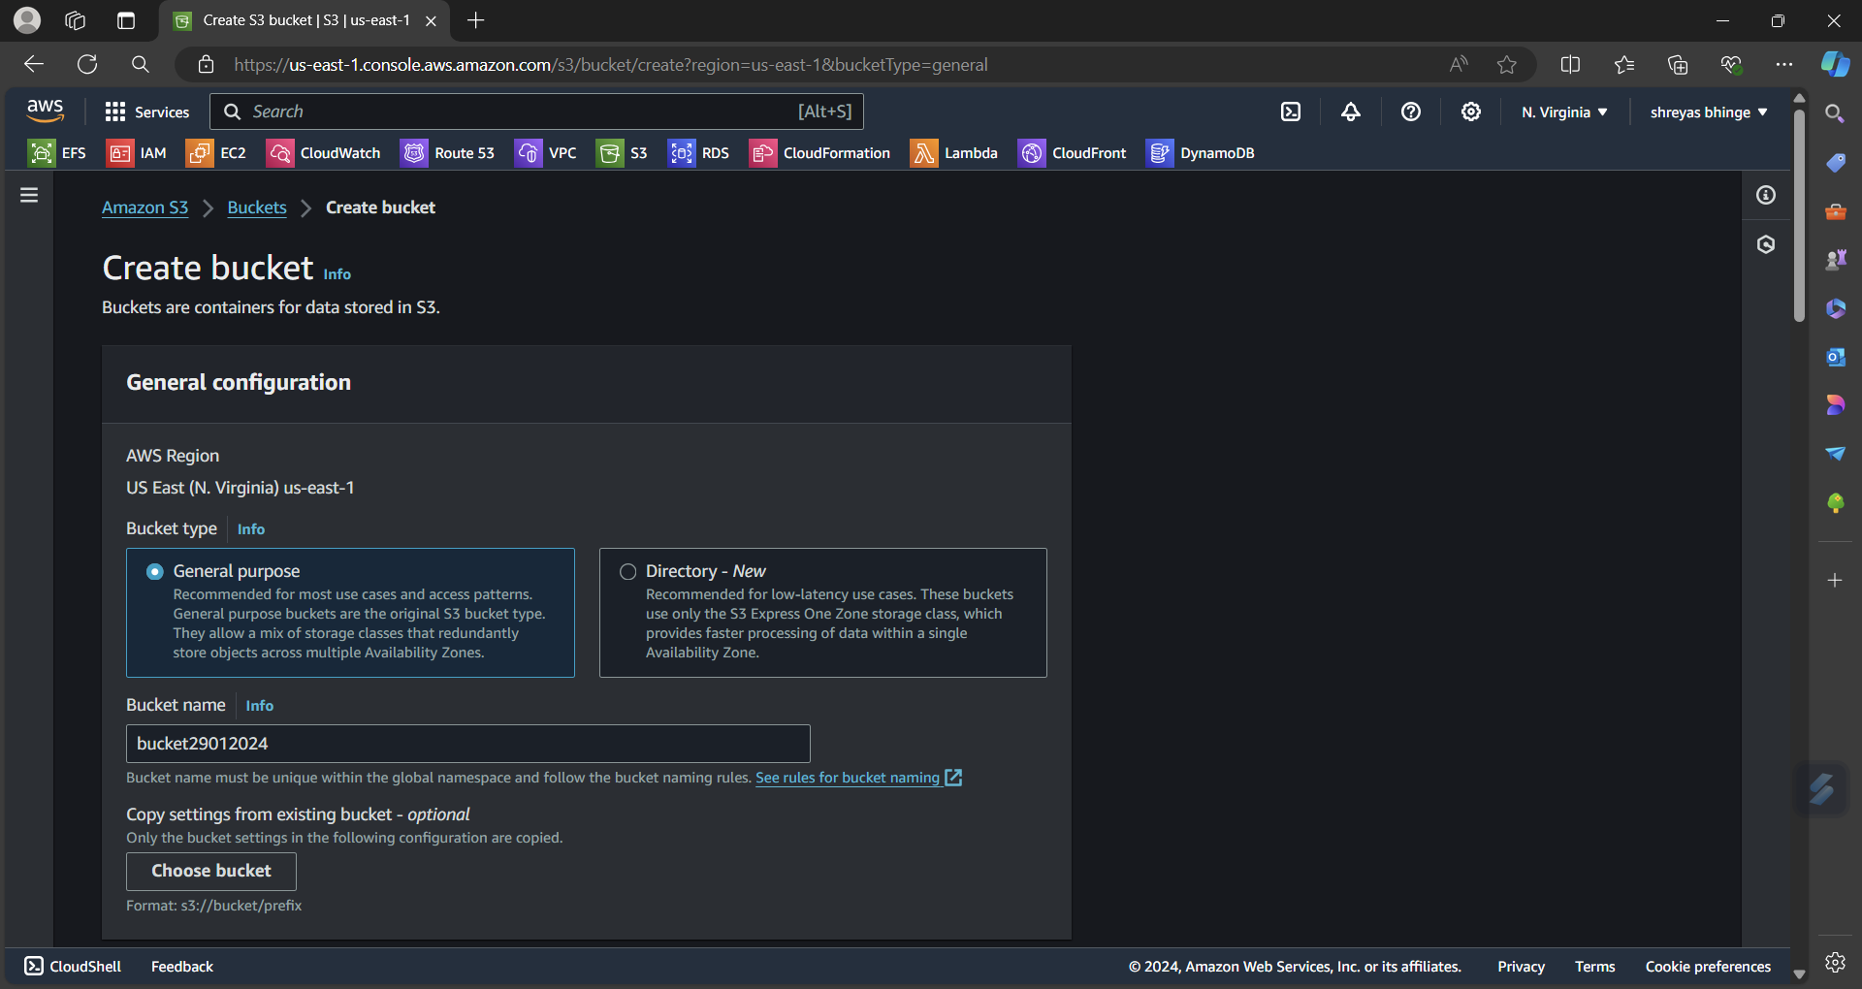

2. Upload 5 objects with different file extensions.

